**Creating a table:**

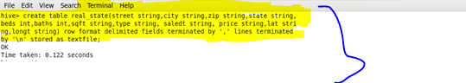

**Load data into table:**

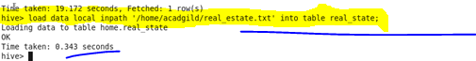

**1.**

**Hive query to find the city wise list all the Condos which is not less than ten thousand.:**

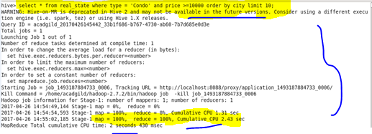

**Output :**

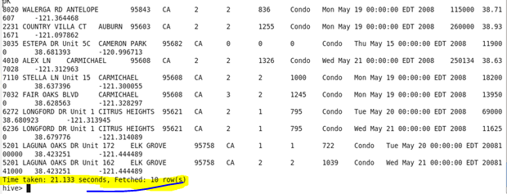

**2.**

**Hive query to find which is the cheapest Condo in CA. name the city,street and price for the Condo:**

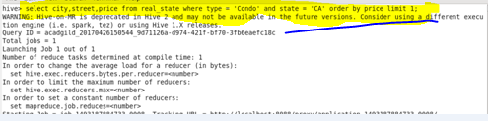

**Output :**

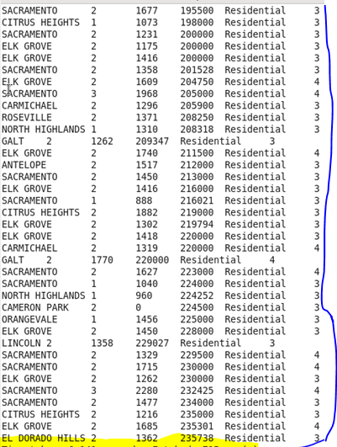

**3.**

**Hive query to list top 5 residency details which lie in the budget of 60000-120000, an area more than 1450, sold after 17th may, min bedroom 3 and,min bathroom 2:**

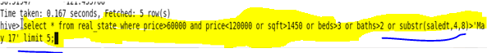

**Output:**

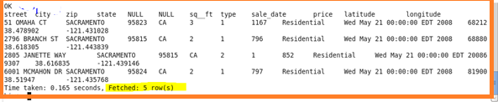

**4.**

**Hive query to separate list of residential apartments with more than 2 beds. Also include columns in following order City,Baths,Sq_feet,Price,flat_type,Beds respectively:**

**C:\Users\612926\Desktop\9.png**

**Output:**

